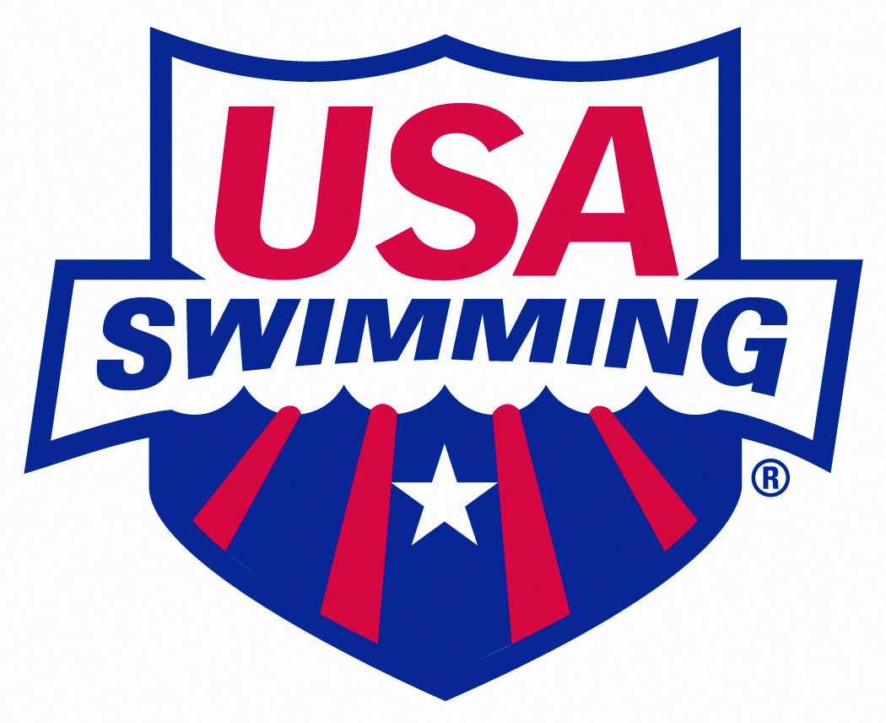
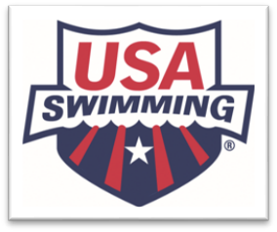
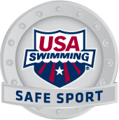
USA Swimming Safe Sport IMPACT Award
Nomination Form

Safe Sport Committee Mission Statement: USA Swimming is committed to safeguarding the well‐being of all of its members, with the welfare of its athlete members as the top priority.

Purpose: The purpose of the Safe Sport Impact Award is to recognize significant achievements by an individual or group who has contributed to the fulfillment of the Safe Sport Committee mission to safeguard all members of USA Swimming from sexual, psychological, emotional and physical abuse.

Nominator
Name: Email Address:
Day Phone: Evening Phone:
Mailing Address: City/State/Zip Code:
Nominee
Name: Email Address:
Day Phone: Evening Phone:
Mailing Address: City/State/Zip Code:
Nominee Information
Is the Nominee a USA Swimming member? Yes No
If yes, what is the Nominee’s LSC?
If the Nominee is not a member of USA Swimming, what is the Nominee’s relationship to USA Swimming?
Nominee’s Qualifications
Please answer these questions on a separate page, and attach your answers to this cover page.
- What are the Nominee’s contributions which promote the mission of the Safe Sport Committee?
- Why or how are the Nominee’s contributions impressive?
Submitting your Nomination
Please submit this nomination (cover page + attached sheet with Nominee’s qualifications) by March 31st to: safesport@usaswimming.org

